Jogging final test
Shaquire Dean
14th August 2021
PRETEST
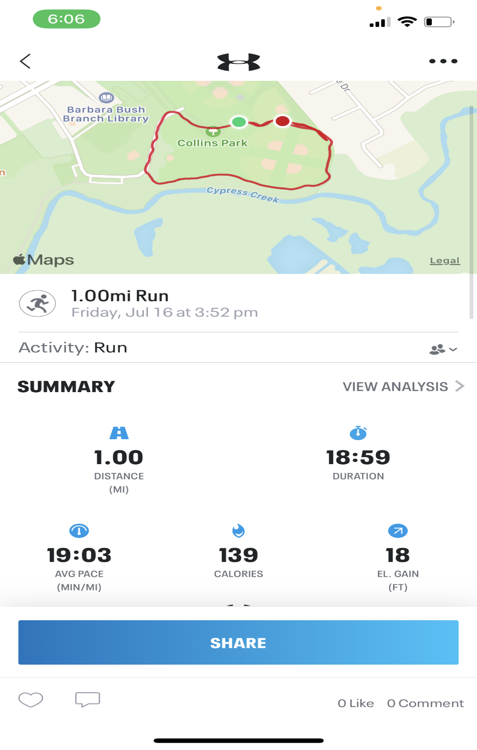

FINAL TEST
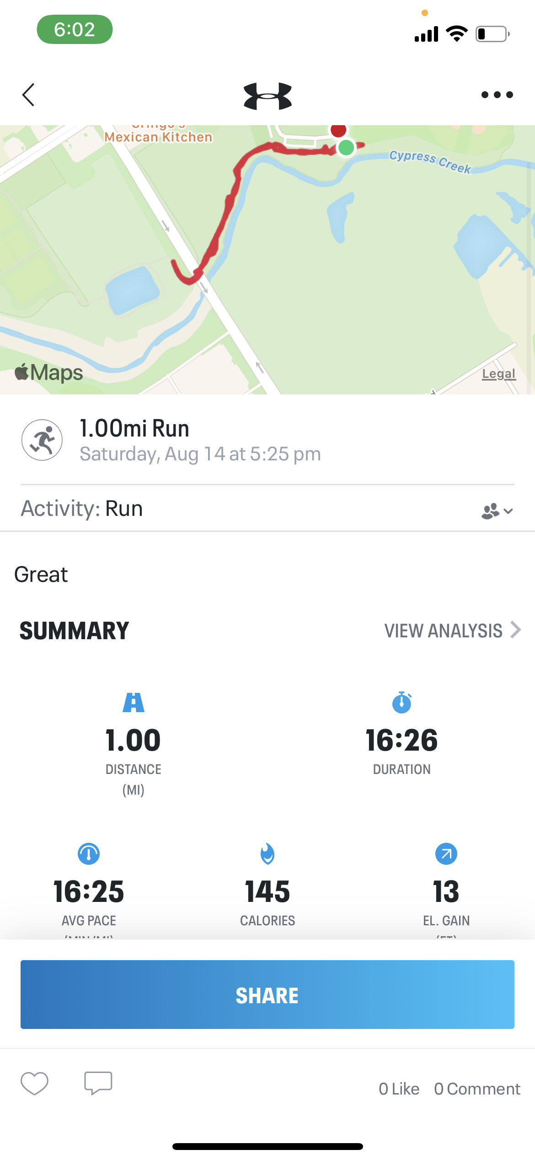
COMPARISON
In comparison of the pretest and the final test, I did make an improvement in my final test but not a big one. I believe I could have done better if I was as consistent as I was when I first started and worked on how I push myself jogging more.

